# Image 1 – malaria.tif

1. **Task-l Preprocessing (5pts)**: Use Linear (i.e. Gaussian) or non-linear (i.e. median, morphological) filtering to smooth the input images and to remove noise.

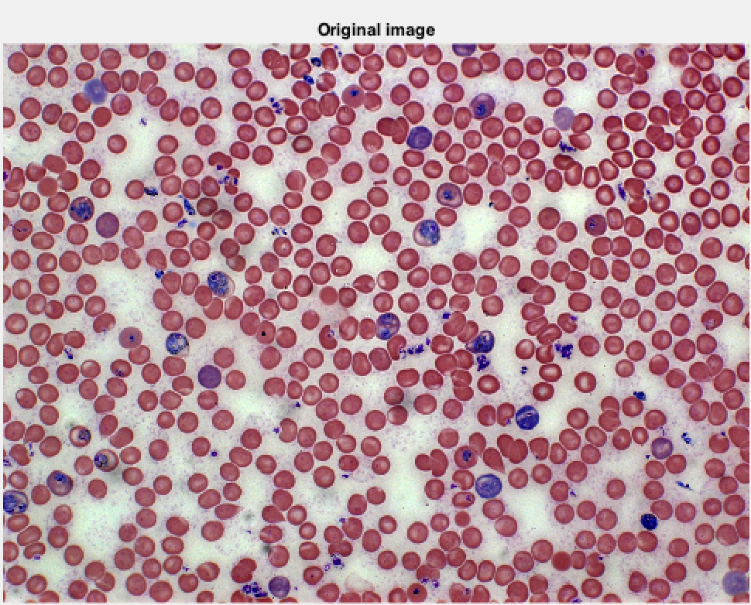

Figure Original Malaria image

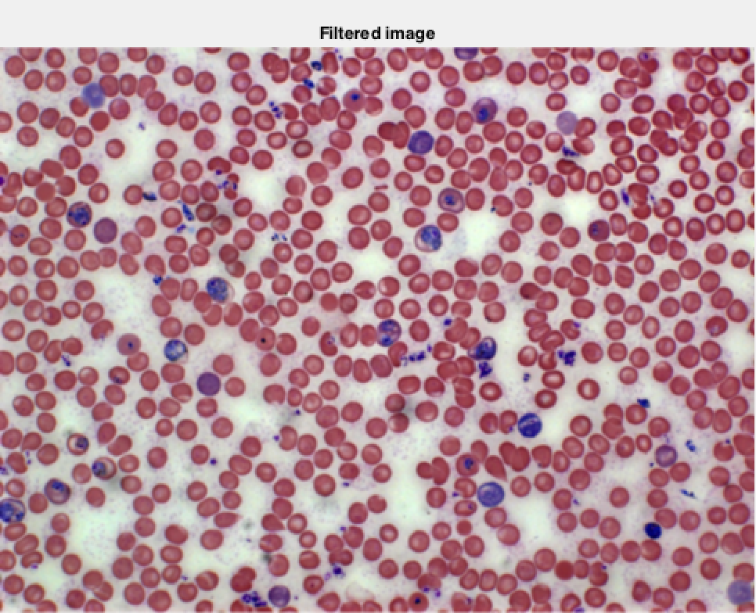

Figure Gaussian filtered Image with σ=2

The malaria.tif (Figure 1) consisting of 3 channels is used as an input. The effects of smoothing is illustrated in Figure 2. A Gaussian filter with $σ=2$ is applied on the original image. We see that the smoothed image is slightly blurred than the original image.

1. **Task-2a Cell/nuclei segmentation using K-means (10pts):** 
   1. Segment the nuclei from the background using k-means clustering method (use Matlab function kmeans).
   2. Use two different feature sets, show and discuss your results.

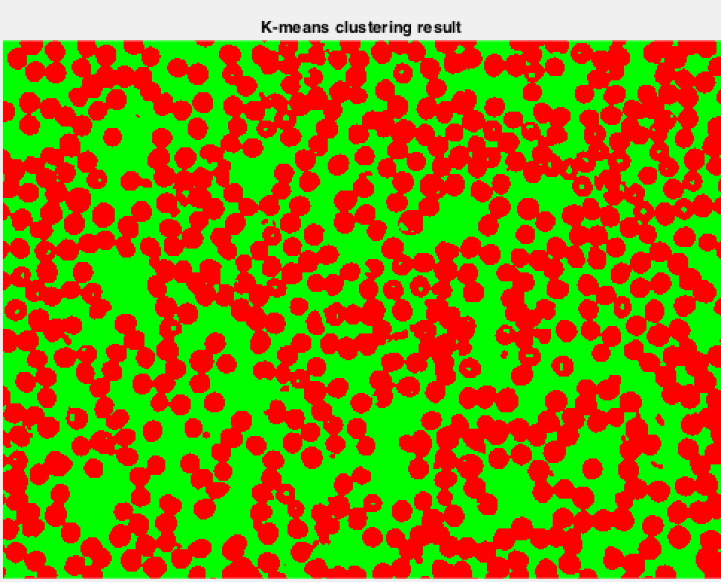

Figure K-means result for 2 clusters

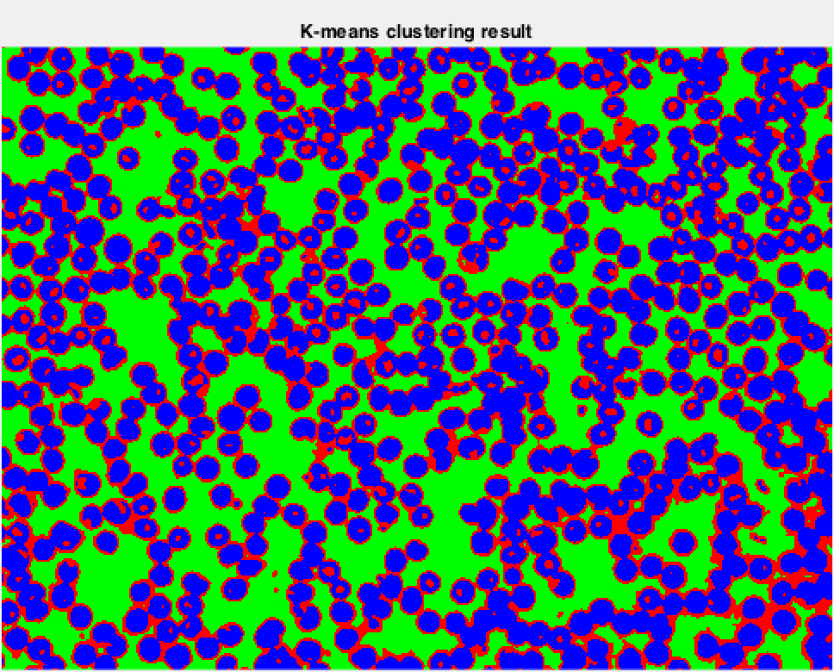

Figure K-means result for 3 clusters

K-means clustering is performed on the smoothed image (Figure 2 ) with varying the number of clusters. Figure 3 illustrates the result of k-means clustering for 2 clusters, where as Figure 4 shows the k-means clustering results for 3 clusters. Consider Figure 4, even though the number of clusters is 3, only 2 clusters (green, blue) are dominant in the image, very few pixels are assigned to cluster represented by red color. This shows that the actual number of clusters present in the image is 2.

The RGB image (Figure 1) has been converted to a gray scale image, and smoothed using Gaussian filter with $σ=2$. Original gray scale image and filtered images are shown in Figure 5, Figure 6 respectively.

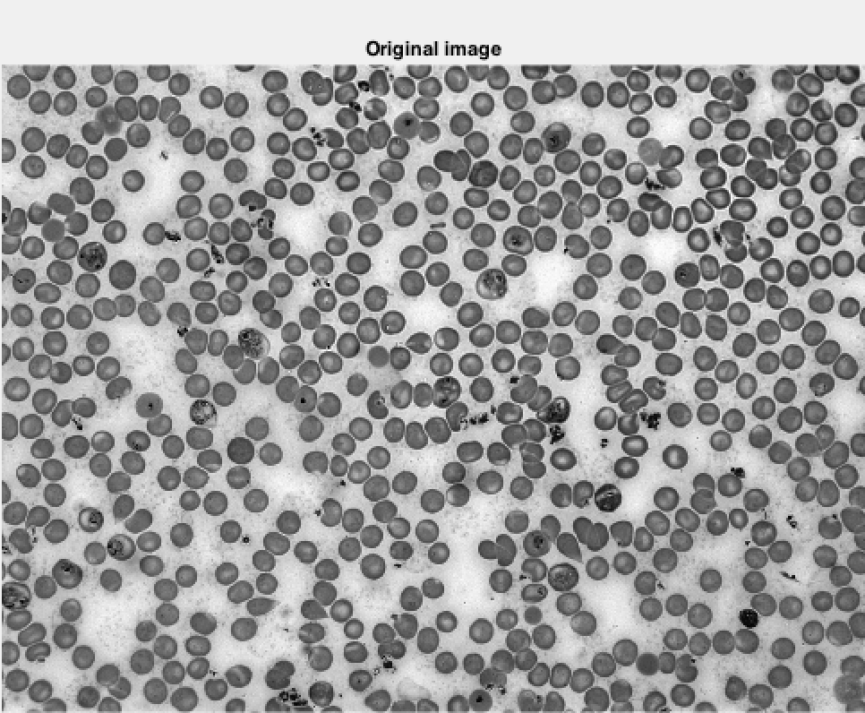

Figure Grayscale image malaria.tif

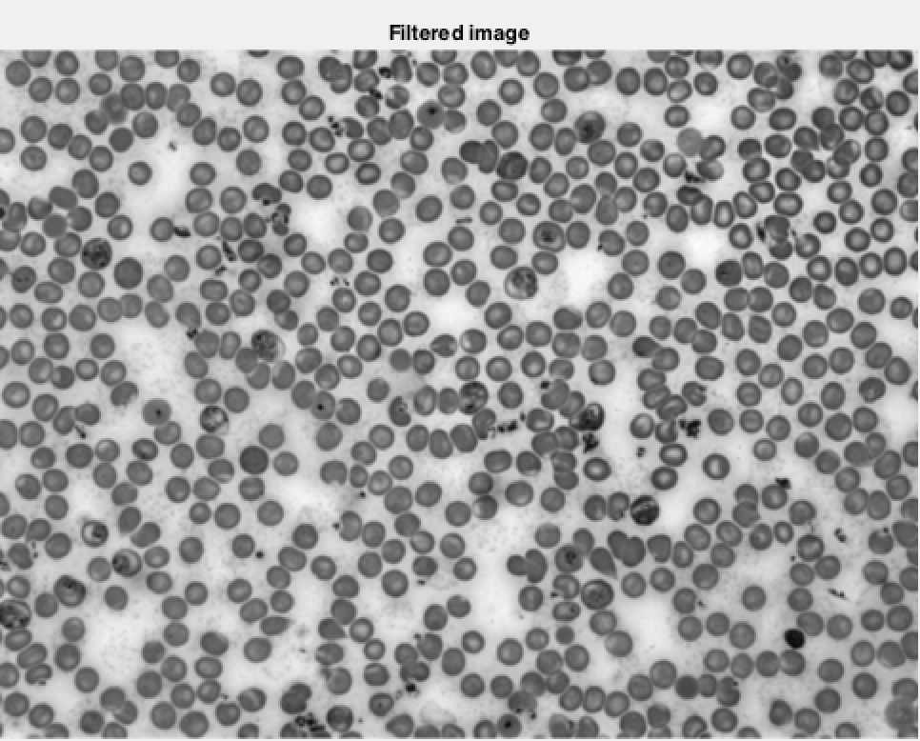

Figure Gaussian smoothed image with $σ$ = 2

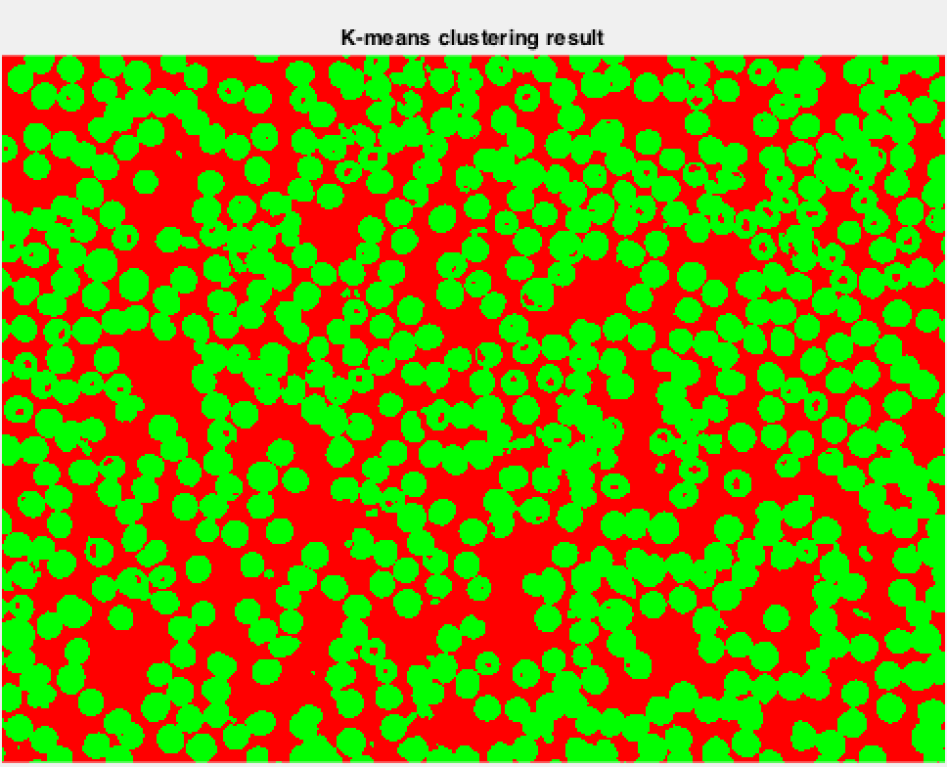

Figure K-means clustering result with 2 clusters

Figure 7 shows the result of k-means clustering on Figure 6 with 2 classes.

# Image 2 - lungCT.jpg

1. **Task-l Preprocessing (5pts)**: Use Linear (i.e. Gaussian) or non-linear (i.e. median, morphological) filtering to smooth the input images and to remove noise.

The lungCT.jpg (Figure 8) is a grayscale image with high signal to noise ratio. Figure 9 shows the smoothed version of Figure 8. A Gaussian filter with $σ=1$ is applied to the original image to get the smoothed image.

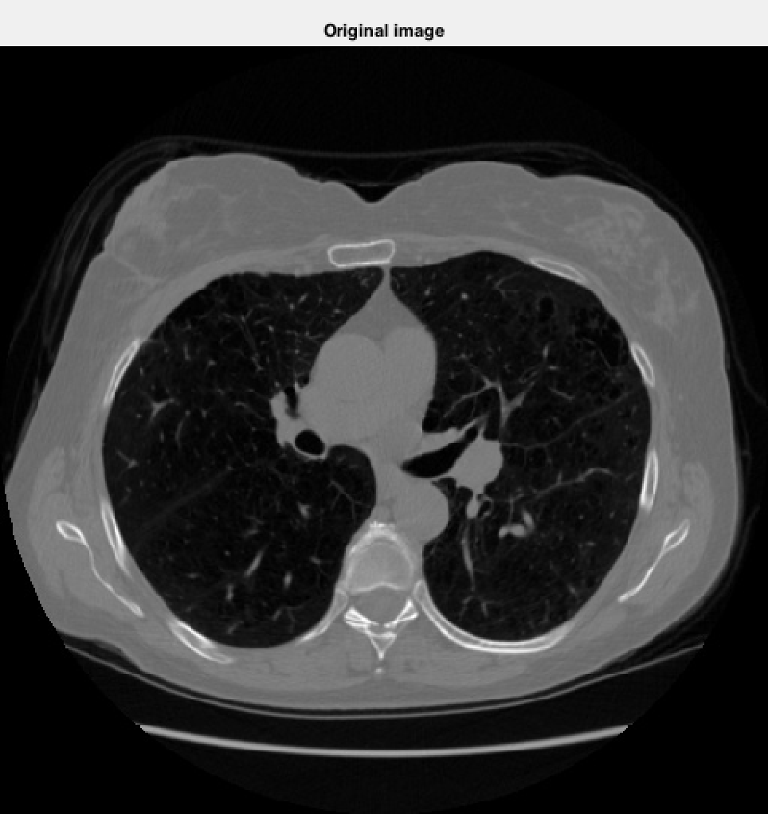

Figure Original lungCT image

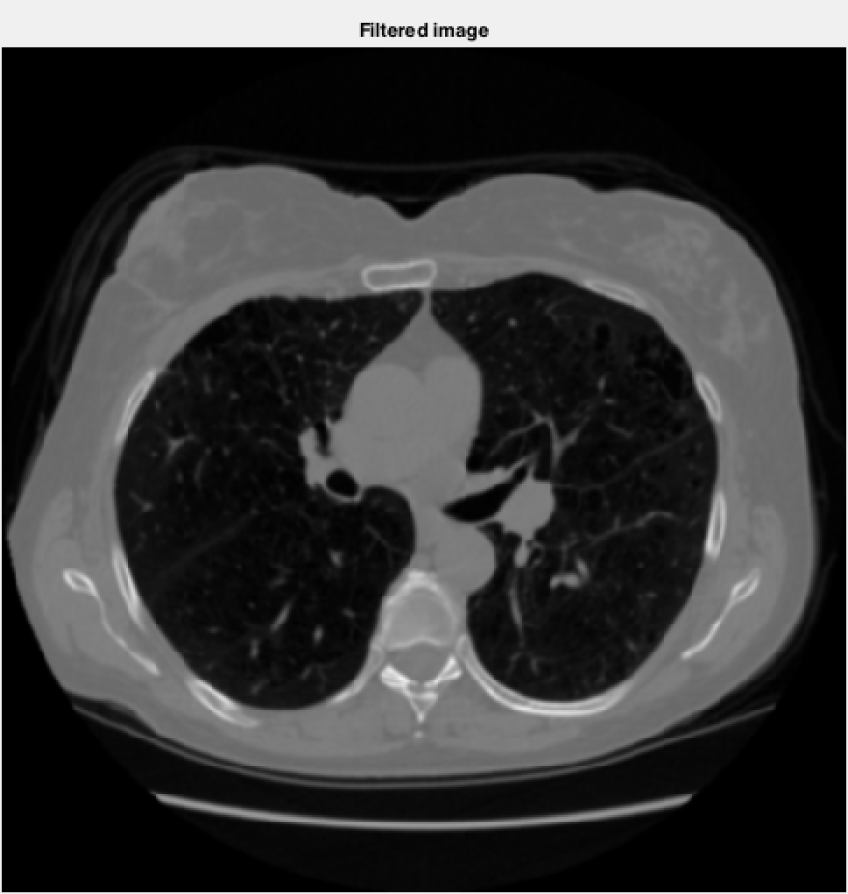

Figure Gaussian smoothed image with $σ$ = 1

1. **Task-2a Cell/nuclei segmentation using K-means (10pts):** 
   1. Segment the nuclei from the background using k-means clustering method (use Matlab function kmeans).
   2. Use two different feature sets, show and discuss your results.

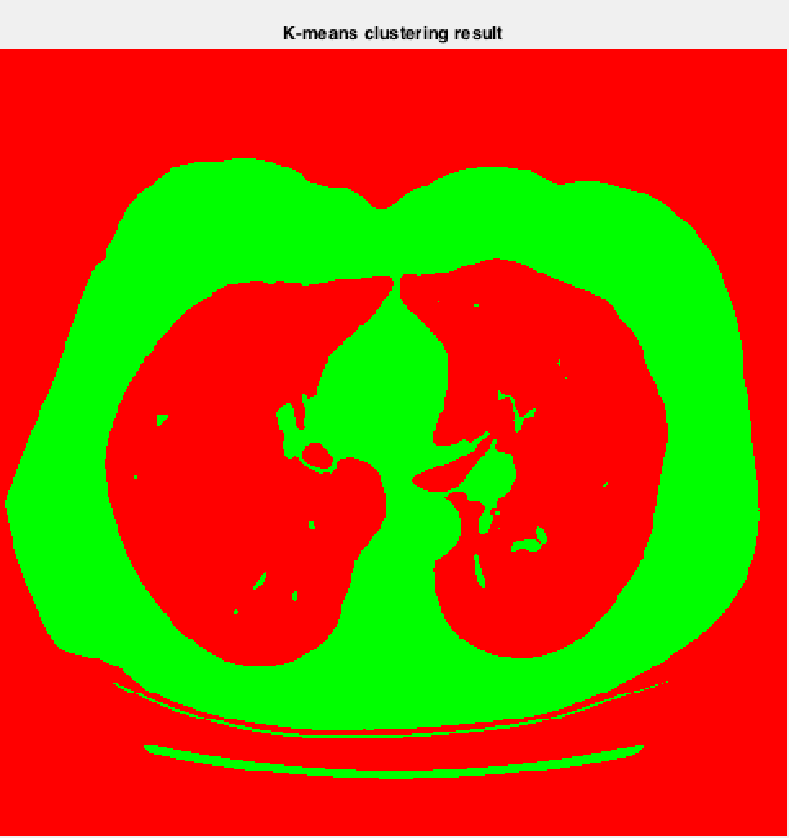

Figure k-means clustering with 2 clusters

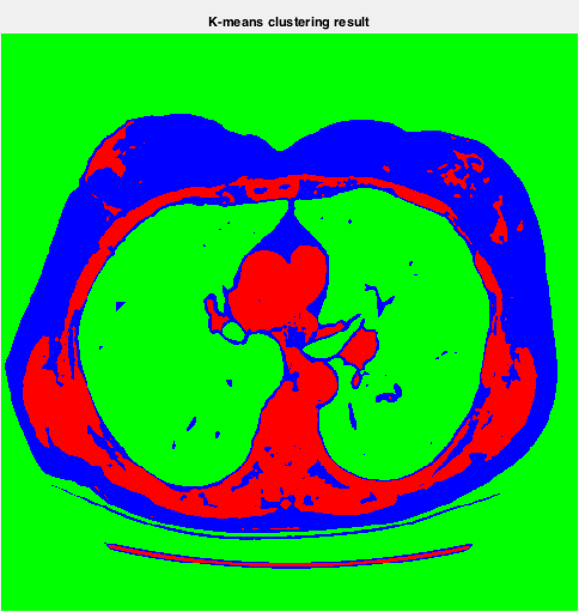

Figure k-means clustering result with 3 clusters

A k-means clustering is performed on the smoothed image (Figure 9) with 2 clusters and 3 clusters. Figure 10 shows the clustering result with 2 classes. The clustering result with 3 classes is shown in Figure 11.

# Image 3 – prostatecancer_grade4.tif

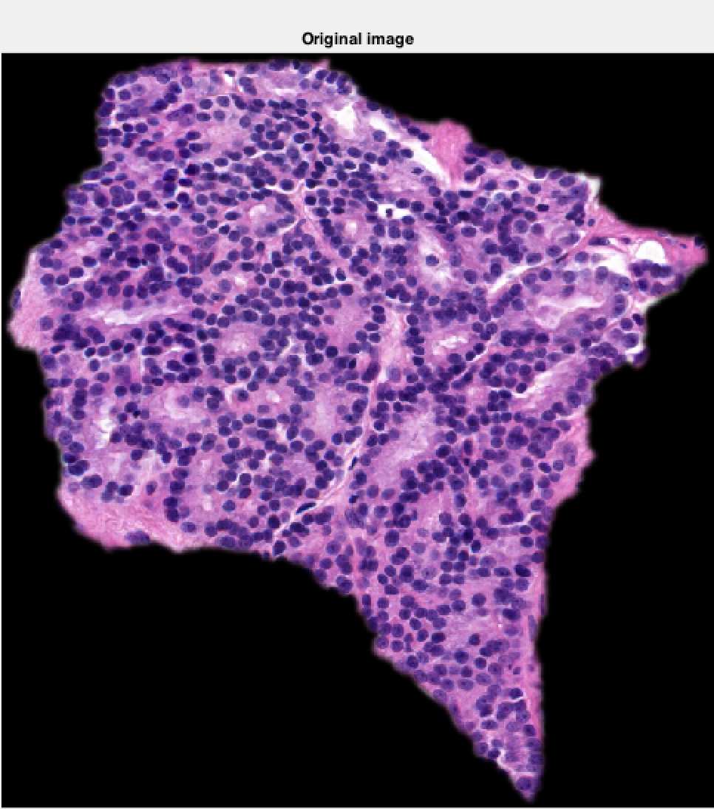

Figure Prostat ecancer original rgb image

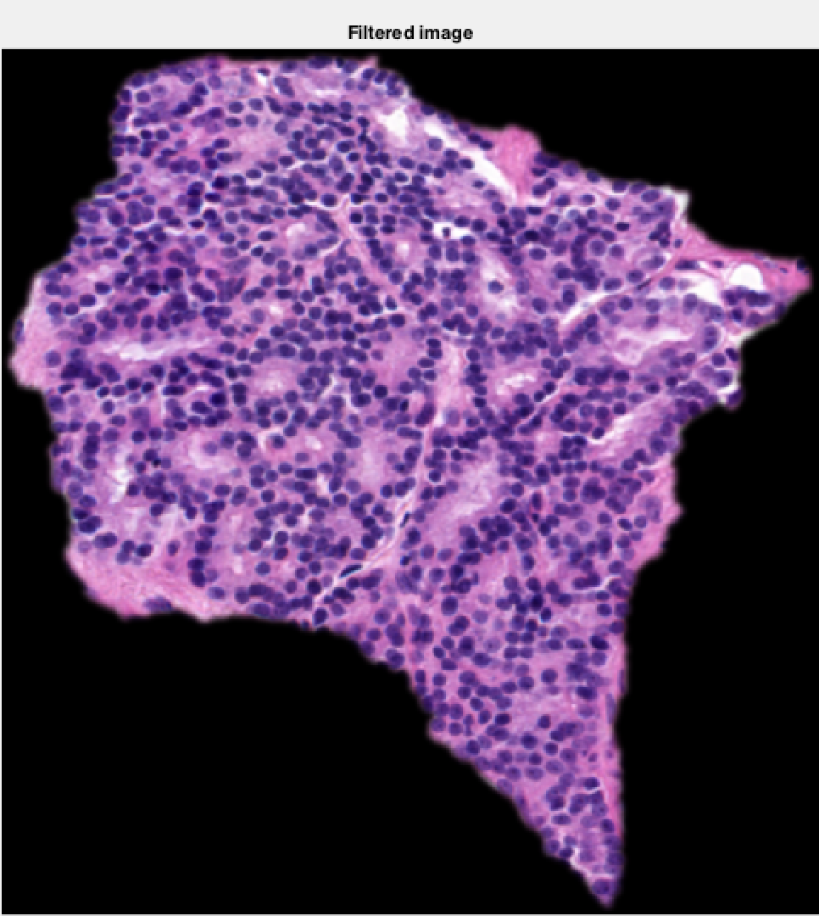

Figure Smoothed image of Figure 12

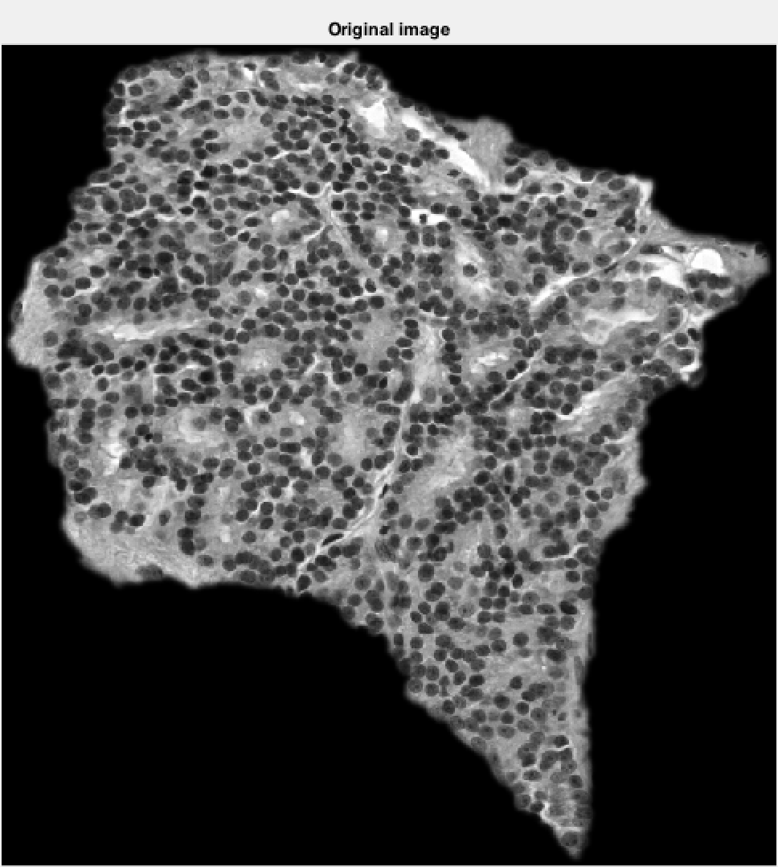

Figure Prostate cancer grayscale image

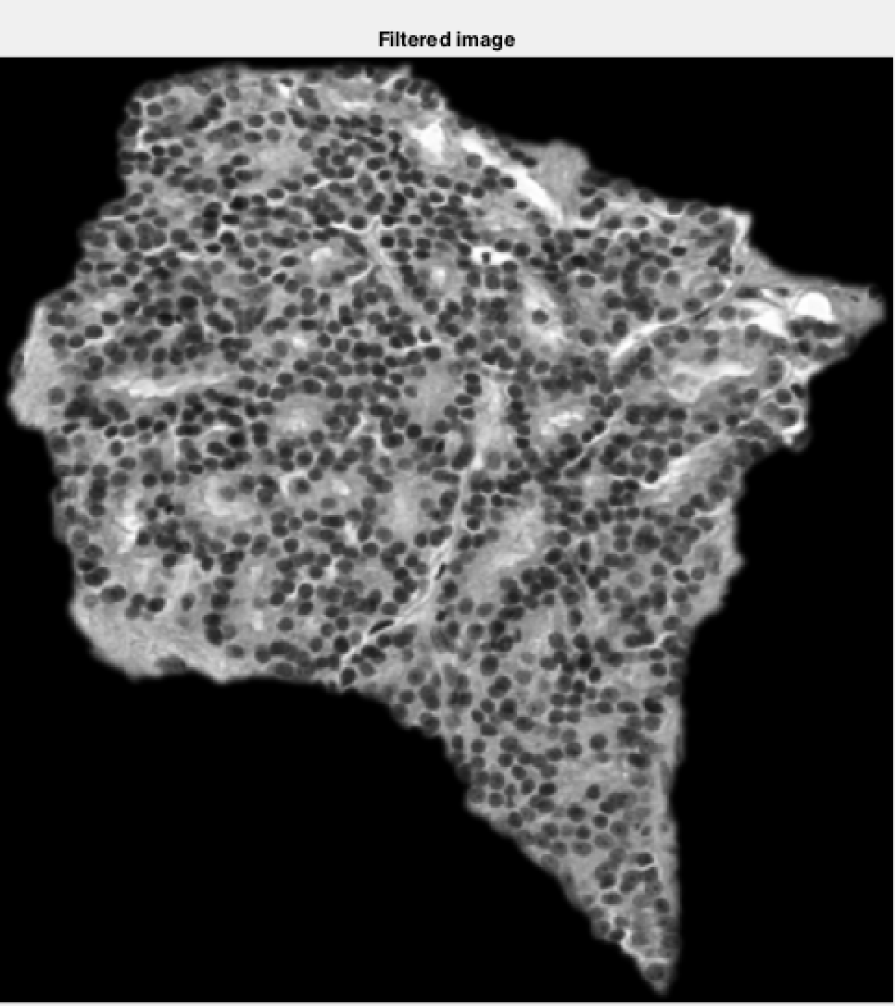

Figure Smoothed version of Figure 14

Figure 12 shows the original prostate cancer image in RGB, Figure 14 shows the grayscale version of the original RGB image. Figure 13, Figure 15 shows the smoothed version of RGB and grayscale image respectively. A Gaussian filter with $σ=1$ is employed for smoothing

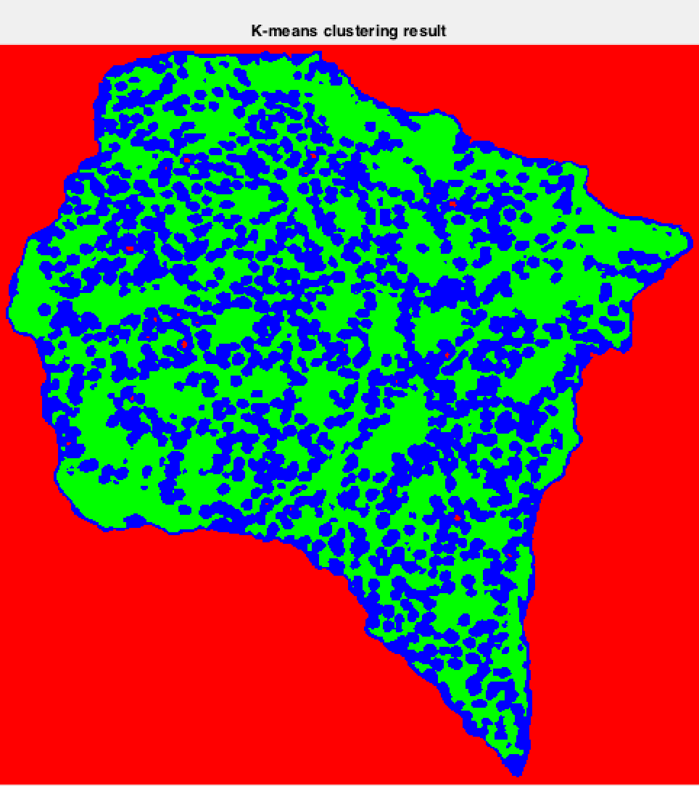

Figure K-means clustering result of Figure 13 with 3 clusters

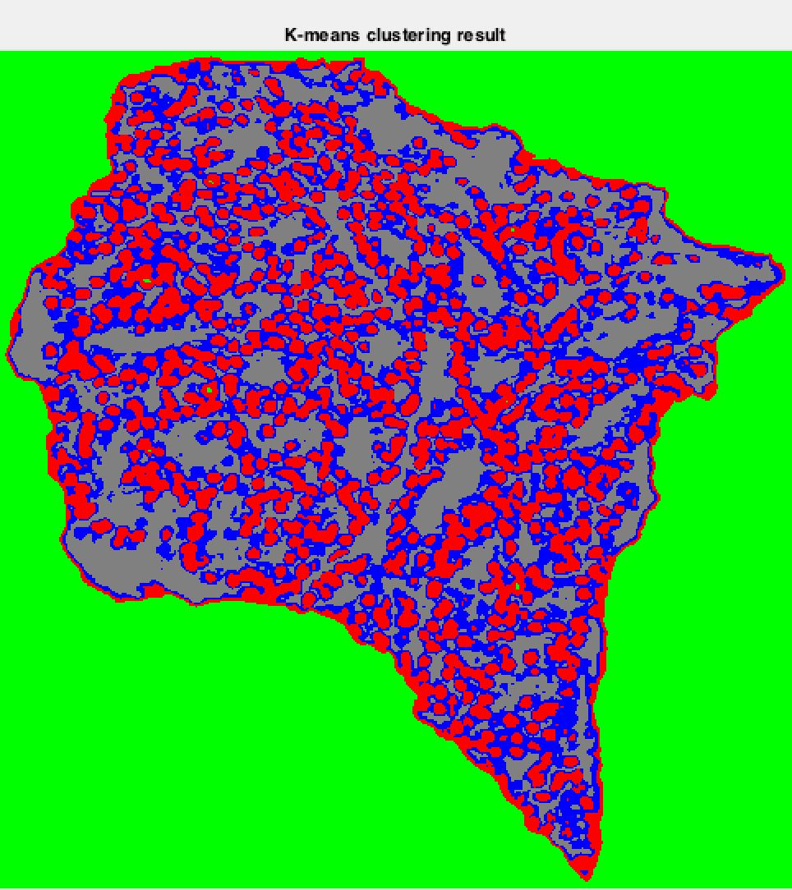

Figure K-means clustering results of Figure 13 with 4 clusters

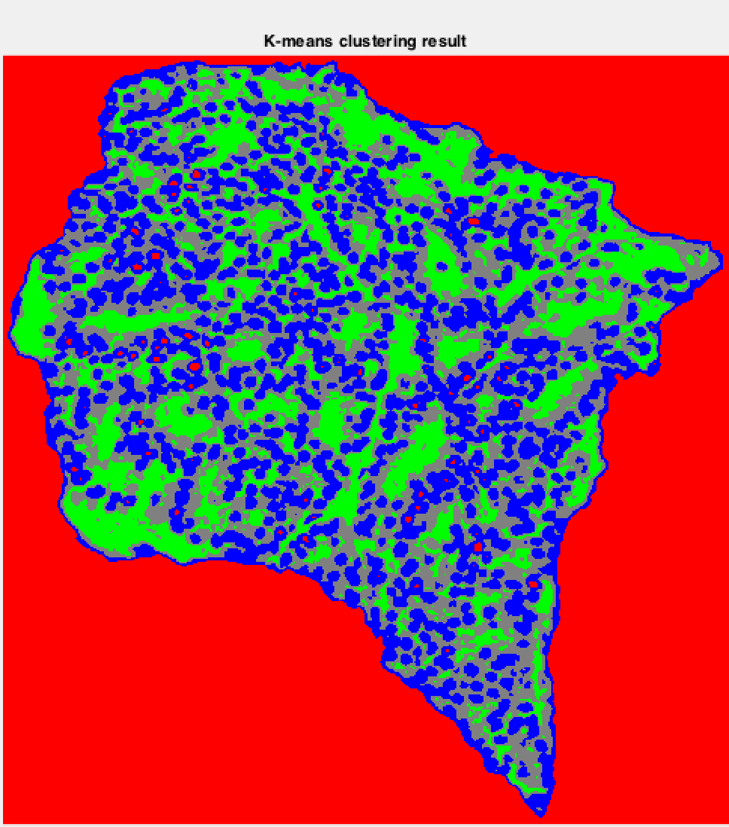

Figure K-means clustering of Figure 15 with 2 clusters

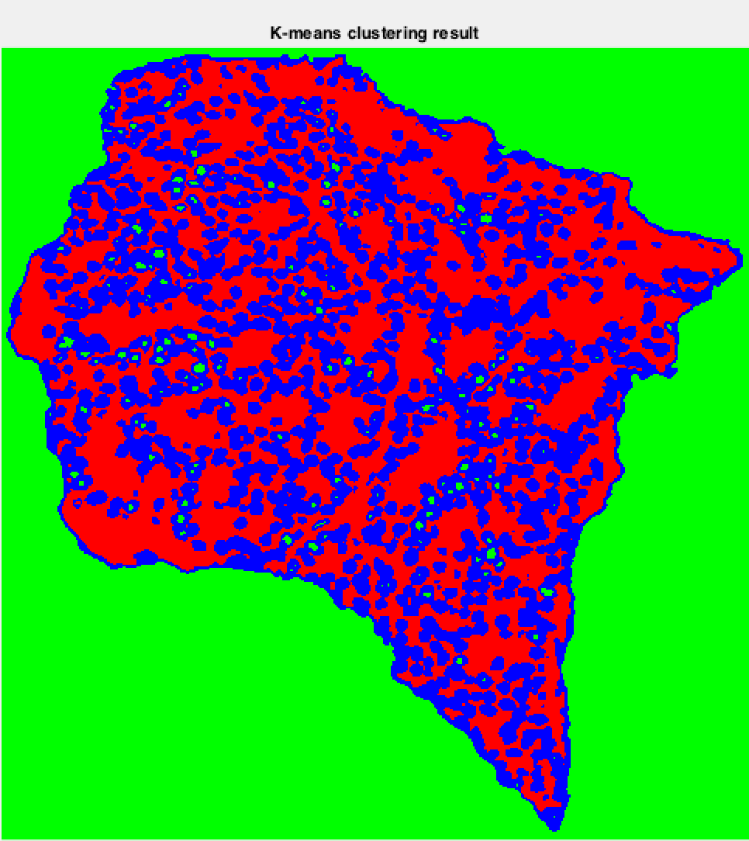

Figure K-means clustering of Figure 15 with 4 clusters

Figure 16, Figure 17, Figure 18, Figure 19 represent the k-means clustering outputs of Figure 13, Figure 15 with 3 and 4 clusters. It is very evident from the output image with 4 clusters that there are only 3 dominant clusters where as the 4 cluster has very few pixels. This shows that the actual number of clusters present in the image is 3.

# Image 3 – prostatecancer_grade4_cropped.tif

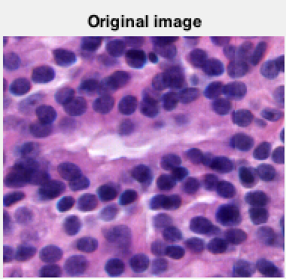

Figure Original image

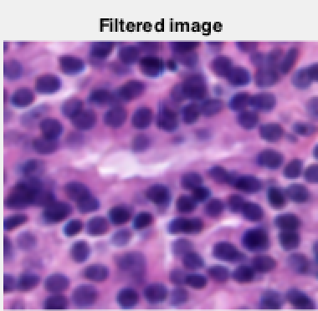

Figure Filtered output

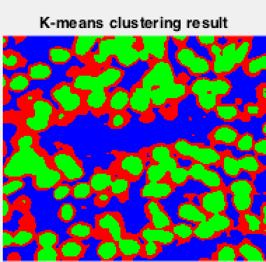

Figure K-means clustering result

Figure 20 illustrates the original image of prostate cancer. The image has been smoothed with Gaussian filter with $σ=1$, the filtered output is displayed in Figure 21. Figure 22 shows the effect of k-means clustering with 3 classes. It can be seen that all the cells are classified into one cluster.

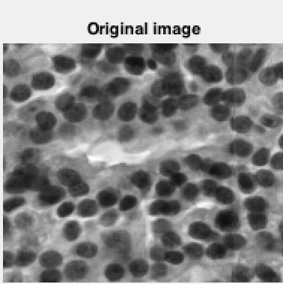

Figure Original image

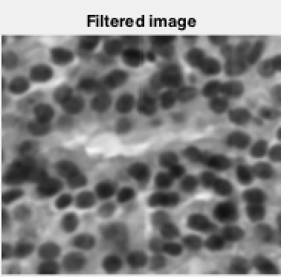

Figure Filtered image

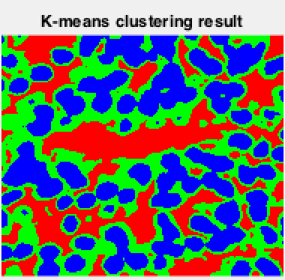

Figure K-means clustering image

Figure 23 displays the grayscale image of Figure 20. The grayscale image has been smoothed with a Gaussian filter of $σ=1$, it is show in Figure 24. A k-means clustering with 3 clusters is performed on the smoothed image. Figure 25 shows the clustering result.